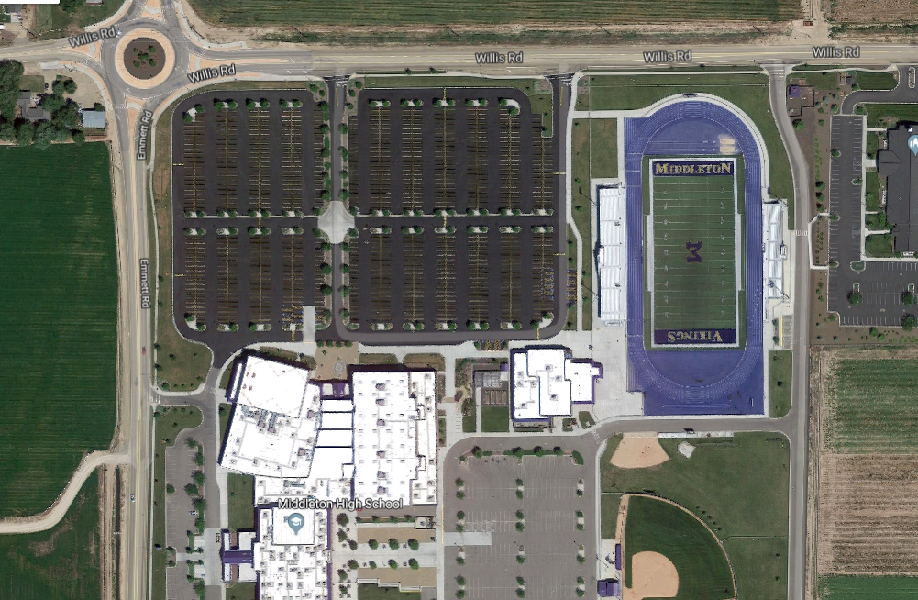State Track Meet Parking Diagram 2019

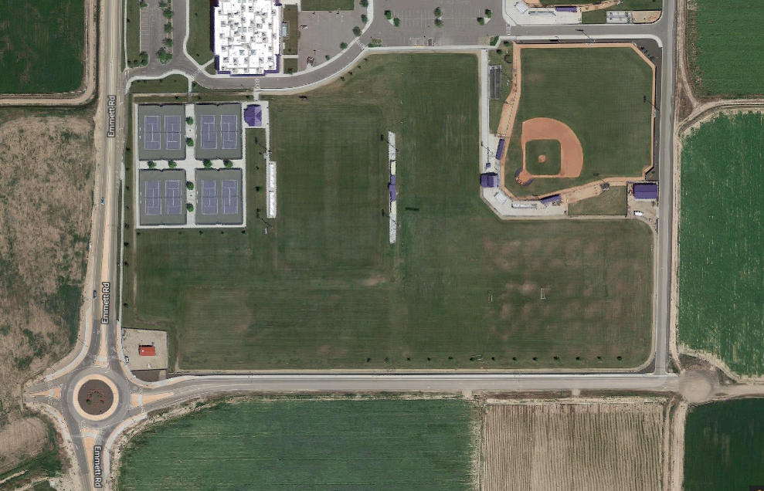

**EXIT**

**EXIT**

**EXIT**

**Drop Off Athletes**

**Drop Off Athletes**

**IHSAA Staff Parking**

**Exit only**

**Buses and IHSAA Staff Only**

**All Cars and Rv’s**

**Bus Parking**

**General Parking**

**RV Parking**